Python

Python Input

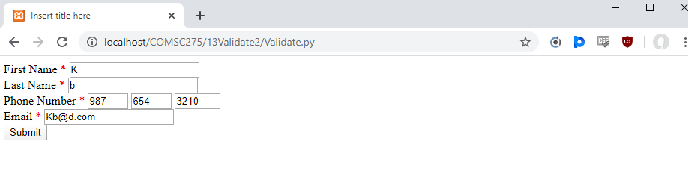

Python Output

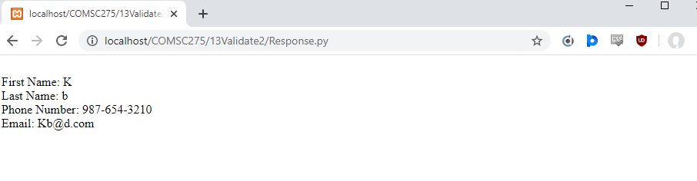

Validate.py

#!/python27/python  
  
  
print("Content_type: 'text/html' \n\n")  
print ('''   
  
<html>  
  
<head>  
  
<meta http-equiv="Content-Type" content="text/html; charset=ISO-8859-1">  
<title>Insert title here</title>  
  
</head>  
  
<body>  
  
<script type="text/javascript">  
  
function validateFname (){  
 //alert("validateFname");//Debugging technique  
  
 var fname,span;  
 var retValue=true;  
  
 var input=document.getElementsByTagName("input");  
 var fname=input[0].value;  
 //Create a span element only if a span with id "idSpanFname" does not exist  
 //(i.e. it had not already been created during a previous call to this function)  
 var span=document.getElementById("idSpanFname");  
  
 if (span==null){  
 var br=document.getElementsByTagName("br");  
 var brFname=br[0];  
 span=document.createElement("span");  
 var parentBrFname = brFname.parentNode;  
 parentBrFname.insertBefore(span, brFname);  
 span.style.color="red";  
 span.id = "idSpanFname";  
 }  
 span.innerHTML = "";  
   
 //alert("fname" + fname);  
   
 if (fname==null || fname=="")  
 {   
 span.innerHTML = "Required field. Enter value.";  
 retValue = false;  
 }  
 else if (!fname.match(/^[A-Za-z]+$/)){   
 span.innerHTML = "Letters only field. Re-enter value.";  
 retValue = false;   
 }  
 return retValue;  
}  
  
function validateLname (){  
 //alert("validateLname");  
  
 var retValue=true;  
  
 var input=document.getElementsByTagName("input");  
 var lname=input[1].value;  
  
 var span=document.getElementById("idSpanLname");  
  
 if (span==null){  
 var br=document.getElementsByTagName("br");  
 var brLname=br[1];  
 span=document.createElement("span");  
 var parentBrLname = brLname.parentNode;  
 parentBrLname.insertBefore(span, brLname);  
 span.style.color="red";  
 span.id = "idSpanLname";  
 }  
  
 span.innerHTML = "";  
   
 //alert("lname" + lname);  
   
 if (lname==null || lname=="")  
 {   
 span.innerHTML = "Required field. Enter value.";  
 retValue = false;  
 }  
 else if (!lname.match(/^[A-Za-z]+$/)){   
 span.innerHTML = "Letters only field. Re-enter value.";  
 retValue = false;   
 }  
 return retValue;  
}  
  
function validatePhone (){  
 //alert("validatePhone");  
  
 var retValue=true;  
   
 var input=document.getElementsByTagName("input");  
 var phone1=input[2].value;  
 var phone2=input[3].value;  
 var phone3=input[4].value;  
  
 var span=document.getElementById("idSpanPhone");  
  
 if (span==null){  
 var br=document.getElementsByTagName("br");  
 var brPhone=br[2];  
 span=document.createElement("span");  
 var parentBrPhone = brPhone.parentNode;  
 parentBrPhone.insertBefore(span, brPhone);  
 span.style.color="red";  
 span.id = "idSpanPhone";  
 }  
  
 span.innerHTML = "";  
   
 //alert('phoneArea: ' + phone1 + ' phonePrefix: ' + phone2 + ' phoneFour: ' + phone3);  
 if ((phone1==null || phone1=="") || (phone2==null || phone2=="") || (phone3==null || phone3==""))  
 {   
 span.innerHTML = "Required field. Enter value.";  
 retValue = false;  
 return retValue;  
 }  
 else if ((!phone1.match(/^\d+$/)) || (!phone2.match(/^\d+$/)) || (!phone3.match(/^\d+$/))){   
 span.innerHTML = "Numbers only field. Re-enter value.";  
 retValue = false;   
 }  
 return retValue;  
}  
  
function validateEmail(){  
 //alert("validateEmail");  
  
 var retValue=true;  
  
 var input=document.getElementsByTagName("input");  
 var email=input[5].value;  
  
 var span=document.getElementById("idSpanEmail");  
  
 if (span==null){  
 var br=document.getElementsByTagName("br");  
 var brEmail=br[3];  
 span=document.createElement("span");  
 var parentBrEmail = brEmail.parentNode;  
 parentBrEmail.insertBefore(span, brEmail);  
 span.style.color="red";  
 span.id = "idSpanEmail";  
 }  
  
 span.innerHTML = "";  
   
   
 //alert("email: " + email);  
 if (email==null || email=="")  
 {   
 span.innerHTML = "Required field. Enter value.";  
 retValue = false;  
 }  
 else if (!email.match(/\S+@\S+\.\S+/)){   
 span.innerHTML = "Must be in email@domain.com format. Re-enter value.";  
 retValue = false;   
 }  
 return retValue;  
}  
  
function validate (){  
 var ret1=true, ret2=true, ret3=true, ret4=true;  
 ret1=validateFname ();  
 ret2=validateLname ();  
 ret3=validatePhone ();  
 ret4=validateEmail ();  
 return (ret1&&ret2&&ret3&&ret4);  
}  
</script>  
  
<form name="frmInfo" onsubmit="return validate()" action="Response.py" method="post">  
   
First Name  
<span style="color:red">*</span>  
<input type="text" name="fname" cols="10"  
 onchange="validateFname()">  
<br />  
  
Last Name  
<span style="color:red">*</span>  
<input type="text" name="lname" cols="10"  
 onchange = "validateLname()">  
<br/>  
  
Phone Number  
<span style="color:red">*</span>  
<input type="text" name="phoneArea" maxlength="3" size="3" placeholder="Area"  
 onchange = "validatePhone()">  
<input type="text" name="phonePrefix" maxlength="3" size="3" placeholder="Prefix"  
 onchange = "validatePhone()">  
<input type="text" name="phoneFour" maxlength="4" size="4" placeholder="Last Four"  
 onchange = "validatePhone()">  
<br/>  
  
Email  
<span style="color:red">*</span>  
<input type="text" name="email" cols="10"  
 onchange = "validateEmail()">  
<br/>  
  
<input type="submit" name="submit" value="Submit">  
  
</form>  
  
</body>  
  
</html>  
''')

Response.py

#!/python27/python  
  
import cgi;  
  
  
f = cgi.FieldStorage()  
fname = f.getvalue('fname')  
lname = f.getvalue('lname')  
phone1 = f.getvalue('phoneArea')  
phone2 = f.getvalue('phonePrefix')  
phone3 = f.getvalue('phoneFour')  
email = f.getvalue('email')  
  
  
print("Content_type: 'text/html' \n\n")  
  
print('''  
<br>  
First Name: {} <br>  
Last Name: {} <br>  
Phone Number: {}-{}-{} <br>  
Email: {} <br>  
'''.format(fname, lname, phone1, phone2, phone3, email))

PHP

PHP Input

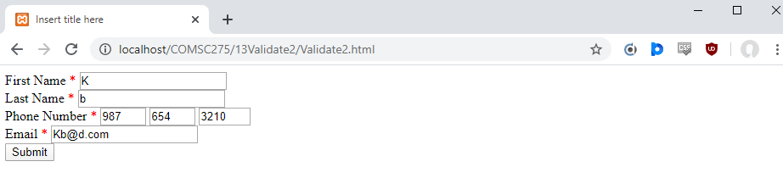

PHP Output

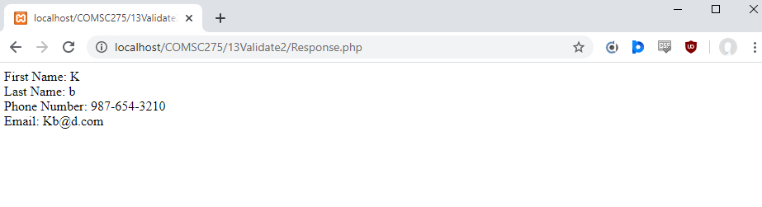

Validate2.html

<html>

<head>

<meta http-equiv="Content-Type" content="text/html; charset=ISO-8859-1">

<title>Insert title here</title>

</head>

<body>

<script type="text/javascript">

function validateFname (){

//alert("validateFname");//Debugging technique

var fname,span;

var retValue=true;

var input=document.getElementsByTagName("input");

var fname=input[0].value;

//Create a span element only if a span with id "idSpanFname" does not exist

//(i.e. it had not already been created during a previous call to this function)

var span=document.getElementById("idSpanFname");

if (span==null){

var br=document.getElementsByTagName("br");

var brFname=br[0];

span=document.createElement("span");

var parentBrFname = brFname.parentNode;

parentBrFname.insertBefore(span, brFname);

span.style.color="red";

span.id = "idSpanFname";

}

span.innerHTML = "";

//alert("fname" + fname);

if (fname==null || fname=="")

{

span.innerHTML = "Required field. Enter value.";

retValue = false;

}

else if (!fname.match(/^[A-Za-z]+$/)){

span.innerHTML = "Letters only field. Re-enter value.";

retValue = false;

}

return retValue;

}

function validateLname (){

//alert("validateLname");

var retValue=true;

var input=document.getElementsByTagName("input");

var lname=input[1].value;

var span=document.getElementById("idSpanLname");

if (span==null){

var br=document.getElementsByTagName("br");

var brLname=br[1];

span=document.createElement("span");

var parentBrLname = brLname.parentNode;

parentBrLname.insertBefore(span, brLname);

span.style.color="red";

span.id = "idSpanLname";

}

span.innerHTML = "";

//alert("lname" + lname);

if (lname==null || lname=="")

{

span.innerHTML = "Required field. Enter value.";

retValue = false;

}

else if (!lname.match(/^[A-Za-z]+$/)){

span.innerHTML = "Letters only field. Re-enter value.";

retValue = false;

}

return retValue;

}

function validatePhone (){

//alert("validatePhone");

var retValue=true;

var input=document.getElementsByTagName("input");

var phone1=input[2].value;

var phone2=input[3].value;

var phone3=input[4].value;

var span=document.getElementById("idSpanPhone");

if (span==null){

var br=document.getElementsByTagName("br");

var brPhone=br[2];

span=document.createElement("span");

var parentBrPhone = brPhone.parentNode;

parentBrPhone.insertBefore(span, brPhone);

span.style.color="red";

span.id = "idSpanPhone";

}

span.innerHTML = "";

//alert('phoneArea: ' + phone1 + ' phonePrefix: ' + phone2 + ' phoneFour: ' + phone3);

if ((phone1==null || phone1=="") || (phone2==null || phone2=="") || (phone3==null || phone3==""))

{

span.innerHTML = "Required field. Enter value.";

retValue = false;

return retValue;

}

else if ((!phone1.match(/^\d+$/)) || (!phone2.match(/^\d+$/)) || (!phone3.match(/^\d+$/))){

span.innerHTML = "Numbers only field. Re-enter value.";

retValue = false;

}

return retValue;

}

function validateEmail(){

//alert("validateEmail");

var retValue=true;

var input=document.getElementsByTagName("input");

var email=input[5].value;

var span=document.getElementById("idSpanEmail");

if (span==null){

var br=document.getElementsByTagName("br");

var brEmail=br[3];

span=document.createElement("span");

var parentBrEmail = brEmail.parentNode;

parentBrEmail.insertBefore(span, brEmail);

span.style.color="red";

span.id = "idSpanEmail";

}

span.innerHTML = "";

//alert("email: " + email);

if (email==null || email=="")

{

span.innerHTML = "Required field. Enter value.";

retValue = false;

}

else if (!email.match(/\S+@\S+\.\S+/)){

span.innerHTML = "Must be in email@domain.com format. Re-enter value.";

retValue = false;

}

return retValue;

}

function validate (){

var ret1=true, ret2=true, ret3=true, ret4=true;

ret1=validateFname ();

ret2=validateLname ();

ret3=validatePhone ();

ret4=validateEmail ();

return (ret1&&ret2&&ret3&&ret4);

}

</script>

<form name="frmInfo" onsubmit="return validate()" action="Response.php" method="post">

First Name

<span style="color:red">*</span>

<input type="text" name="fname" cols="10"

onchange="validateFname()">

<br />

Last Name

<span style="color:red">*</span>

<input type="text" name="lname" cols="10"

onchange = "validateLname()">

<br/>

Phone Number

<span style="color:red">*</span>

<input type="text" name="phoneArea" maxlength="3" size="3" placeholder="Area"

onchange = "validatePhone()">

<input type="text" name="phonePrefix" maxlength="3" size="3" placeholder="Prefix"

onchange = "validatePhone()">

<input type="text" name="phoneFour" maxlength="4" size="4" placeholder="Last Four"

onchange = "validatePhone()">

<br/>

Email

<span style="color:red">*</span>

<input type="text" name="email" cols="10"

onchange = "validateEmail()">

<br/>

<input type="submit" name="submit" value="Submit">

</form>

</body>

</html>

Response.php

<?php

$fname = $_REQUEST['fname'];

$lname = $_REQUEST['lname'];

$phone1 = $_REQUEST['phoneArea'];

$phone2 = $_REQUEST['phonePrefix'];

$phone3 = $_REQUEST['phoneFour'];

$email = $_REQUEST['email'];

print(

"

First Name: $fname<br>

Last Name: $lname<br>

Phone Number: $phone1-$phone2-$phone3<br>

Email: $email

");

?>